Exercise 7: Financial Forecasting
package exno_7;
public class FinancialForecast {

// Recursive method
public static double futureValueRecursive(double principal, double rate, int years) {
if (years == 0) {
return principal;
}
return (1 + rate) * futureValueRecursive(principal, rate, years - 1);
}
// Memoization method
public static double futureValueMemo(double principal, double rate, int years, double[] memo{
if (years == 0)
return principal;

if (memo[years] != 0)
return memo[years];

memo[years] = (1 + rate) * futureValueMemo(principal, rate, years - 1, memo);
return memo[years];
}
}
Main.java
package exno_7;
public class Main {
public static void main(String[] args) {
double principal = 15000; // Initial Investment
double rate = 0.08; // 8% annual growth
int years = 6;
System.out.println("Initial Investment : ₹" + principal);
System.out.println("Annual Growth Rate : " + (rate * 100) + "%");
System.out.println("Number of Years : " + years);
System.out.println("\nUsing Recursive Method");
double future1 = FinancialForecast.futureValueRecursive(principal, rate, years);
System.out.printf("Future Value = ₹%.2f\n", future1);
System.out.println("\nUsing Memoization Method");
double memo[] = new double[years + 1];
double future2 = FinancialForecast.futureValueMemo(principal, rate, years, memo);
System.out.printf("Future Value = ₹%.2f\n", future2);
}
}

OUTPUT:
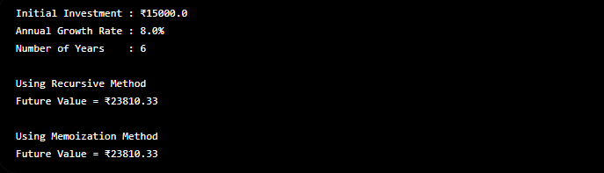

Exercise 2 : E-commerce Platform Search Function
Code:
=> Product.java
package exno_2;
public class Product implements Comparable<Product> {
private int productId;
private String productName;
private String category;
public Product(int productId, String productName, String category) {
this.productId = productId;
this.productName = productName;
this.category = category;
}
public int getProductId() {
return productId;
}
public String getProductName() {
return productName;
}
public String getCategory() {
return category;
}
@Override
public int compareTo(Product other) {
return this.productId - other.productId;
}
@Override
public String toString() {
return "[" + productId + "] " + productName + " - " + category;
}
}

=> SearchEngine.java
package exno_2;
public class SearchEngine {
// Linear Search
public static Product linearSearch(Product[] products, int id) {
for (Product product : products) {
if (product.getProductId() == id) {
return product;
}
}
return null;
}
// Binary Search (products must be sorted by productId)
public static Product binarySearch(Product[] products, int id) {
int left = 0;
int right = products.length - 1;
while (left <= right) {
int mid = left + (right - left) / 2;
int midId = products[mid].getProductId();
if (midId == id) return products[mid];
else if (id < midId) right = mid - 1;
else left = mid + 1;
}
return null;
}
}

=> Main.java
package exno_2;
import java.util.Arrays;
public class Main {
public static void main(String[] args) {
Product[] products = {
new Product(102, "Phone", "Electronics"),
new Product(101, "Shirt", "Clothing"),
new Product(103, "Laptop", "Electronics"),
new Product(104, "Book", "Stationery")
};
System.out.println("Linear Search:");
Product result1 = SearchEngine.linearSearch(products, 103);
System.out.println(result1 != null ? result1 : "Product not found");
// Sort for binary search
Arrays.sort(products);
System.out.println("\nBinary Search:");
Product result2 = SearchEngine.binarySearch(products, 103);
System.out.println(result2 != null ? result2 : "Product not found");
}
Output:
